Colors in Java

When you use a *setColor()* or *setBackgroundColor()*, or any other method to tell Java what color you want to use, you have to put something in the brackets to specify the color. The thing you put in brackets will specify an existing color, or create a new color for Java to use.

### You use an existing color object like this:

*c.setColor(Color.red);* or

*c.setBackgroundColor(Color.blue);*

Possible color names are:

black, blue, cyan, dark_gray, gray, green, light_gray, magenta, orange, pink, red, white, and yellow.

### Or you can create your own color object like this:

*c.setColor(new Color(128, 138, 255)); or*

*c.setBackgroundColor(new Color(0, 100, 0));*

The three numbers specify how much of the colors red, green and blue to mix. 255 is the maximum amount, and 0 is the minimum. *new Color(0, 0, 0 )* is black, *new Color(255, 255, 255 )* is white, *new Color(255, 0, 0)* is bright red, *new Color(100, 0, 0)* is dull red, and so on.

### How do you find out the red/green/blue values for a good color?

One way to do this is to go into word, then open the font color tool, select **more colors**, and the **custom** tab. Then choose the color you want, and copy down the red, green, and blue values shown.

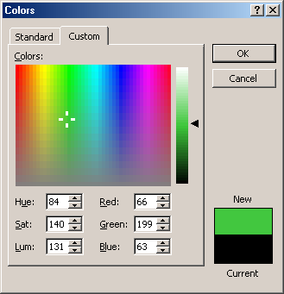

Get red, green, and blue values

Choose color

Your color

### Transparency

If you create a new color with a fourth 0-255 value, it will be used as the “alpha” value, which controls how transparent the color is. When you draw in a partially transparent color, instead of covering over other shapes and text on the screen, they will still show through. Try it, it’s cool!